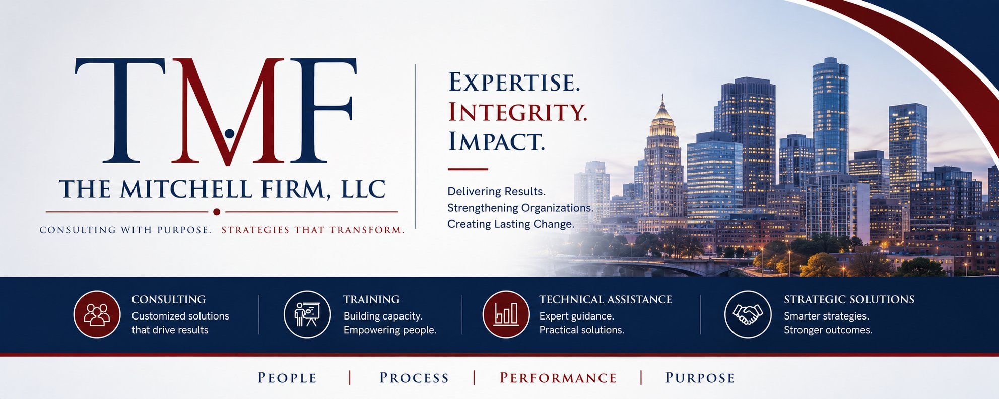

TRAINING CATALOG
The Mitchell Firm offers a suite of evidence-informed, practitioner-designed training programs for justice agencies, nonprofits, and government partners. All courses are available in multiple formats and can be customized to your organizational context.
TRACK 1: JUVENILE JUSTICE REFORM & DISPARITY REDUCTION

JJR-101 | Introduction to Juvenile Detention Alternatives (JDAI) | ⏱ Half-Day (4 hrs) | 🎯 New Practitioners / Administrators

COURSE OVERVIEW  This foundational course introduces participants to the Juvenile Detention Alternatives Initiative — its history, core strategies, and evidence base. Participants examine how jurisdictions can reduce unnecessary detention while maintaining public safety and improving youth outcomes.  DELIVERY FORMATS:  In-person workshop | Virtual instructor-led | Hybrid | Train-the-Trainer (add-on) | LEARNING OUTCOMES  - Describe the history and core components of JDAI  - Identify key data indicators used in detention decision-making  - Apply JDAI principles to local detention assessment practices  - Articulate the relationship between detention reduction and racial equity  - Develop an action plan for initial JDAI implementation steps

JJR-201 | Racial and Ethnic Disparities: Data, Root Causes, and Systemic Solutions | ⏱ Full-Day (8 hrs) | 🎯 Agency Staff / Leadership Teams

COURSE OVERVIEW  An advanced exploration of racial and ethnic disparities in juvenile justice — from data collection and analysis through root cause examination to actionable disparity reduction strategies. Participants leave equipped to lead disparity reduction work in their jurisdictions.  DELIVERY FORMATS:  Full-day in-person intensive | Multi-session virtual series (4 x 2 hrs) | Agency retreat format | LEARNING OUTCOMES  - Analyze disparity data using DMC core requirements and JJDPA standards  - Identify systemic, structural, and individual-level drivers of disparity  - Apply R/ED frameworks to decision points across the juvenile justice continuum  - Design a disparity reduction strategy grounded in community engagement  - Communicate disparity findings to diverse stakeholder audiences

JJR-301 | Probation Transformation: From Compliance to Connection | ⏱ Full-Day (8 hrs) or 2-Day | 🎯 Probation Officers / Supervisors / Directors

COURSE OVERVIEW  This course challenges traditional compliance-driven probation models and introduces evidence-based, developmental approaches that reduce recidivism, build youth-officer relationships, and promote equitable supervision practices. Combines framework instruction with case study analysis.  DELIVERY FORMATS:  In-person workshop (1 or 2 days) | Virtual modular series (6 x 90 min) | Leadership cohort format | LEARNING OUTCOMES  - Distinguish between compliance-driven and connection-centered probation models  - Apply a developmental lens to supervision conditions and case planning  - Use strength-based assessment tools to support youth success  - Identify and reduce racially biased practices in supervision decisions  - Lead team-level change toward transformative probation practices

TRACK 2: POLICY, ADVOCACY & SYSTEM LEADERSHIP

PAL-101 | Policy into Practice: From Brief to Implementation | ⏱ Half-Day (4 hrs) | 🎯 Policy Staff / Advocates / Agency Leaders

COURSE OVERVIEW  Bridges the gap between policy development and real-world implementation. Participants examine the anatomy of effective policy briefs, explore strategies for stakeholder alignment, and practice translating research and recommendations into actionable change.  DELIVERY FORMATS:  Half-day in-person | 2-session virtual workshop | Conference breakout format | LEARNING OUTCOMES  - Develop a policy brief structure aligned with decision-maker needs  - Apply a stakeholder analysis framework to identify allies and obstacles  - Translate data and research into compelling policy narratives  - Design an implementation roadmap with accountability checkpoints  - Navigate organizational and legislative environments for policy change

PAL-201 | Federal Compliance Essentials: JJDPA Core Requirements | ⏱ Half-Day (4 hrs) | 🎯 SAG Members / State Agency Staff / Grantees

COURSE OVERVIEW  A practical, plain-language guide to the Juvenile Justice and Delinquency Prevention Act's four core requirements — deinstitutionalization of status offenders, separation, jail removal, and disproportionate minority contact (DMC). Designed for staff responsible for compliance monitoring and reporting.  DELIVERY FORMATS:  In-person half-day | 90-minute virtual overview | Custom compliance training for SAG members | LEARNING OUTCOMES  - Identify and define each of the JJDPA's four core requirements  - Navigate OJJDP compliance monitoring and reporting systems  - Assess current jurisdiction status across all four requirements  - Develop corrective action plans in response to compliance gaps  - Communicate compliance expectations to local and state stakeholders

TRACK 3: ORGANIZATIONAL CAPACITY & LEADERSHIP DEVELOPMENT

OLC-101 | Leading Justice Reform: Skills for Change Agents | ⏱ Full-Day (8 hrs) | 🎯 Emerging & Mid-Level Leaders

COURSE OVERVIEW  Designed for justice professionals who are stepping into leadership roles, this course builds the skills needed to lead reform efforts from within — including coalition building, managing resistance, using data to make the case for change, and sustaining reform momentum over time.  DELIVERY FORMATS:  Full-day in-person | Multi-session cohort (4 x 2 hrs) | Conference workshop or keynote + workshop combo | LEARNING OUTCOMES  - Apply adaptive leadership frameworks to justice reform challenges  - Build and sustain cross-sector coalitions for system change  - Use data storytelling to influence decision-makers and funders  - Navigate organizational resistance and manage change processes  - Develop a personal leadership roadmap for sustained reform impact

OLC-201 | Equity-Centered Strategic Planning for Justice Organizations | ⏱ 2-Day Intensive | 🎯 Executive Teams / Board Members / Program Directors

COURSE OVERVIEW  A facilitated, two-day strategic planning experience that helps organizations embed racial equity into their mission, programs, and culture. Combines organizational assessment, visioning, and planning — resulting in a concrete equity-centered action plan ready for implementation.  DELIVERY FORMATS:  2-day in-person intensive (facilitated retreat format) | Virtual over 4 half-days | Custom hybrid | LEARNING OUTCOMES  - Conduct an equity audit of current organizational programs and policies  - Articulate an equity vision and connect it to organizational mission  - Identify structural barriers and design equity-centered interventions  - Develop a 12-month equity action plan with measurable indicators  - Build internal accountability structures for equity commitments

DELIVERY FORMATS & CUSTOMIZATION

🏫  In-Person Workshop  Half-day, full-day, or multi-day formats. Fully facilitated with materials, activities, and participant workbooks included. |  | 💻  Virtual Instructor-Led  Live virtual sessions via Zoom or Teams. Available as single sessions or multi-part series. Includes breakout activities. |  | 💡  Train-the-Trainer  Equip your staff to deliver training internally. Includes facilitation guide, slide decks, and coaching support. |  | ⚙️  Custom Design  No existing course fits? We design from scratch. Share your audience, goals, and timeline — we build the curriculum.

Inquire About Training
All training programs can be customized for your organization's needs, audience, and timeline. Volume pricing available for multi-day and multi-course engagements.
reginamitchell@tmfconsulting.org • (202) 670-4052 • www.themitchellfirm.org

