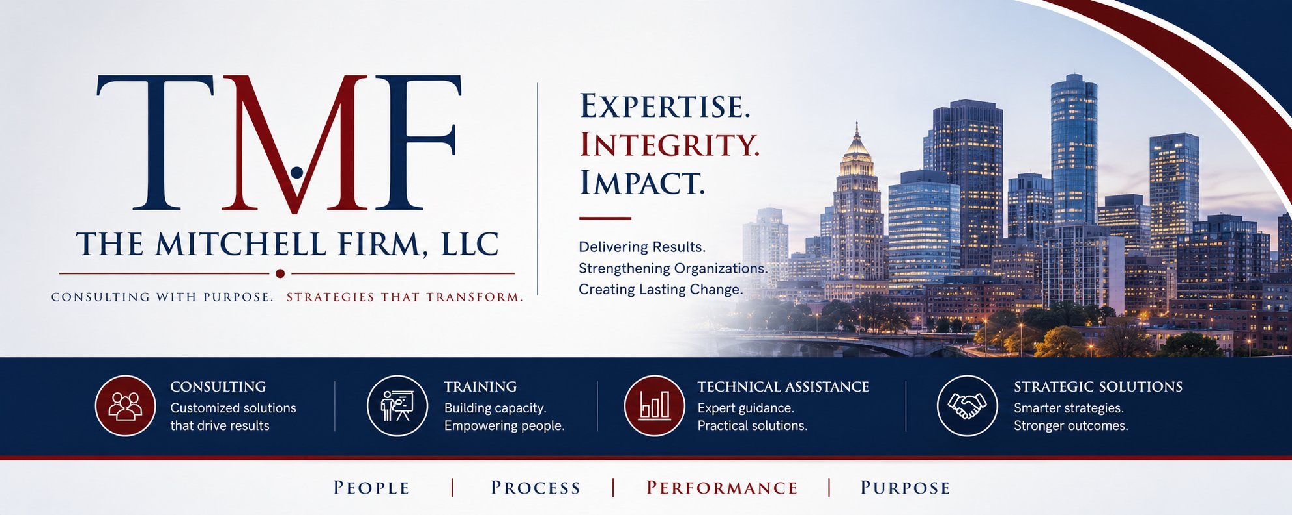

EXECUTIVE SERVICE MENU
The Mitchell Firm, LLC provides high-impact consulting, training, and technical assistance to government agencies, foundations, and nonprofits working to transform the juvenile and criminal justice landscape. Engagements are tailored to your context, capacity, and goals.
CONSULTING SERVICE CATEGORIES

⚖️  Juvenile Justice Reform  Evidence-informed consulting to transform how jurisdictions serve youth — from detention reduction to system redesign. Rooted in decades of frontline and statewide leadership.  DELIVERABLES INCLUDE:  ▪ Disparity reduction strategies  ▪ JDAI site support & review  ▪ Detention alternatives assessment  ▪ Youth diversion program design  ▪ Stakeholder engagement planning |  | 📋  Policy Development & Analysis  Translate research and best practices into actionable policy — from legislative briefs to administrative guidance — ensuring your work is grounded, compliant, and implementation-ready.  DELIVERABLES INCLUDE:  ▪ Policy briefs and white papers  ▪ Legislative analysis and testimony prep  ▪ Federal compliance guidance  ▪ Administrative rule review  ▪ Advocacy toolkit development |  | 🔍  Racial & Ethnic Disparity Reduction  Data-driven technical assistance to identify, understand, and reduce racial and ethnic disparities across the justice continuum — with community-centered, sustainable solutions.  DELIVERABLES INCLUDE:  ▪ Disparity analysis and reporting  ▪ R/ED Coordinator support  ▪ Implicit bias training design  ▪ Community engagement strategies  ▪ DMC core requirements guidance

🏗️  Probation Transformation  Redesign probation practices to be developmentally appropriate, equity-centered, and outcome-driven — reducing recidivism and supporting successful reentry and reintegration.  DELIVERABLES INCLUDE:  ▪ Caseload review and restructuring  ▪ Risk/needs assessment guidance  ▪ Conditions of supervision reform  ▪ Staff development curriculum  ▪ Performance metric frameworks |  | 📊  Program Evaluation & Accountability  Design and manage evaluations that demonstrate impact, support continuous improvement, and satisfy funder and federal reporting requirements with rigor and clarity.  DELIVERABLES INCLUDE:  ▪ Logic model development  ▪ Data collection tool design  ▪ Process and outcome evaluation  ▪ Grant reporting support  ▪ Dashboard and indicator design |  | 🎓  Training & Technical Assistance  Customized, practitioner-informed training and TA to build capacity at every level — from frontline staff to senior leadership — across multiple delivery formats.  DELIVERABLES INCLUDE:  ▪ Curriculum design and delivery  ▪ Train-the-trainer programs  ▪ Webinar and workshop facilitation  ▪ Coaching and peer learning  ▪ Resource guide development

ENGAGEMENT OPTIONS

PROJECT-BASED  Defined scope, timeline, and deliverables. Ideal for toolkits, assessments, training curricula, policy briefs, and evaluations.  ▪ Clear deliverables and milestones  ▪ Fixed or phased timeline  ▪ Competitive flat-fee pricing  ▪ Final report and presentation |  | RETAINER / ONGOING  Sustained partnership for organizations with ongoing reform work, requiring consistent strategic guidance and support over time.  ▪ Monthly strategy sessions  ▪ Priority responsiveness  ▪ Ongoing TA and coaching  ▪ Quarterly progress reviews |  | TRAINING & KEYNOTE  Custom-designed or signature training sessions and keynote presentations for conferences, convenings, and staff development events.  ▪ Half-day and full-day formats  ▪ Virtual or in-person delivery  ▪ CEU/credit-eligible design  ▪ Pre/post assessments available |  | ADVISORY / BOARD  Strategic advisory roles for initiatives, task forces, commissions, or boards seeking subject-matter expertise in justice reform.  ▪ Committee and board service  ▪ Expert review and feedback  ▪ Public convening facilitation  ▪ Strategic planning advisory

OUR ENGAGEMENT PROCESS

01  Discovery  We learn your context, goals, constraints, and stakeholders. |  | 02  Proposal  We deliver a tailored scope of work, timeline, and budget. |  | 03  Engagement  We do the work — with transparency and regular check-ins. |  | 04  Delivery  Final deliverables, presentation, and implementation support. |  | 05  Sustainability  We build your capacity to sustain change long after our engagement ends.

Ready to Get Started?
Schedule a complimentary 30-minute discovery call to discuss your needs and explore how The Mitchell Firm can support your work.
reginamitchell@tmfconsulting.org • (202) 670-4052 • www.themitchellfirm.org

